Innovation in olive-growing. Proximal sensing LiDAR for tree volume estimation.
M. Balestra^{1*}, S.Chiappini¹, E.Marcheggiani¹, MD Abdul Mueed Choudhury¹ and A. Galli¹
¹Department of Agricultural, Food and Environmental Sciences - Università Politecnica delle Marche. Via Brecce Bianche 10, 60131 Ancona,
{m.balestra, m.choudhury, s.chiappini}@pm.univpm.it; {a.galli, e.marcheggiani}@univpm.it

Keywords. Olive Tree, Crown Volume, DSS, MLS, Point Cloud
Abstract. The olive tree is one of the most widespread Mediterranean plants, characterizing the historical landscape and deeply rooted in the local traditions. Indeed, among the wide variety of quality foods of the Mediterranean diet, it is possible to find olive oil. The olive tree cultivation requires specific attention and dedicated pruning techniques, which is a key issue in the tradition of olive tree cultivation. The most suitable shape for the tree crown ensures the best harvesting conditions, balanced solar radiation and a good foliage distribution. These conditions get to yield the best tradeoff between the highest quality standard of the olives and the harvested quantity. There are various cultivation forms, and each one requires experienced pruners to decide what limbs to cut, following specific techniques. At the cutting edge of the research in smart farming, LiDAR (Light Detection And Ranging) offers a promising field of innovation (Colaço et al., 2017) of the pruning stages. The point cloud reconstruction of a single olive tree and the acquisition of valuable metrics are critical to innovating the harvesting methods, including creating a dedicated decision support system (DSS). The present study used the “Kaarta Stencil-2”, a Mobile Laser Scanner (MLS) technology, to rebuild and render individual olive trees by point clouds (Fig.1), supporting the pruning activity. The study area is located in central Italy, in the municipality of Cartoceto, in the Marche region, where a Geographical Indication acknowledges the oil produced. Indeed, it is a typical product and it is included in the protected designation of origin (PDO). It is possible to compute the tree’s metrics (i.e. diameters, heights, the wood volume and the crown volume). The crown volume, in particular, was calculated using two algorithms: Convex hull and Alpha shape. The aim is to understand which algorithm performs the best to assess the volume of the canopy after the intervention of a professional pruner. The volumes resulting from these algorithms have been compared with those usually measured in the field, taking crown size measurements and empirical formulas. These latter assume that the shape of the olive tree canopy is either a parabolic shape or a toroidal shape. The toroidal shape is arguably more suitable because the pruning technique applied in the detected olive tree resulted in a canopy similar to this geometric figure. By comparing the volumes obtained, it was concluded that the Convex hull algorithm provides similar volumetric assessment as that computed using the parabolic shape.
In contrast, the Alpha shape algorithm estimated a volume close to the toroidal empirical formula. The wood volume was then calculated using the Quantitative Structure Models (QSM) (Brede et al., 2019) algorithm (Fig.2), which formed a hierarchical collection of cylinders to estimate the total volume after a data cleaning in the open-source software CloudCompare. These processes, if automated, can be used in the future to integrate a DSS that will assist the farmers.

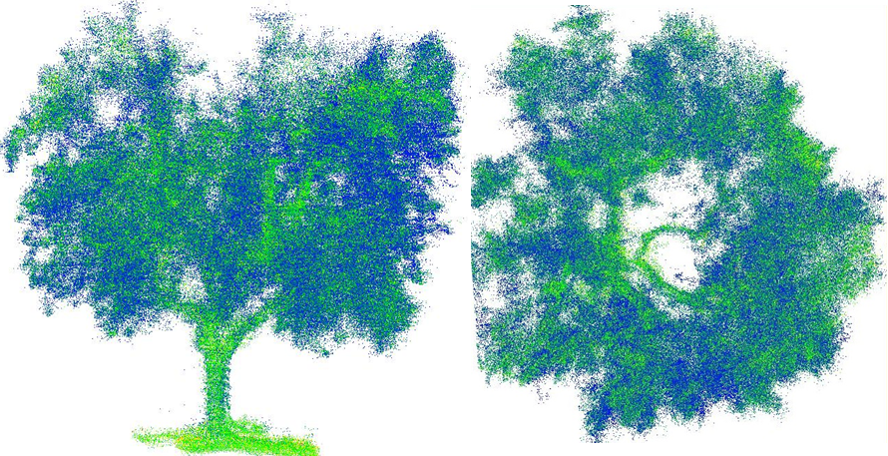
Figure 1 Frontal and nadiral view of the post-pruning olive tree sample

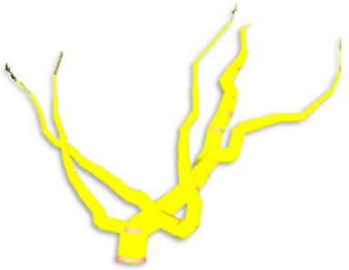
Figure 2 Tree structure reconstruction through QSM alghoritm

References
Brede, B. et al. (2019) ‘Non-destructive tree volume estimation through quantitative structure modelling: Comparing UAV laser scanning with terrestrial LIDAR’, Remote Sensing of Environment, 233(January), p. 111355. doi: 10.1016/j.rse.2019.111355.
Colaço, A. F. et al. (2017) ‘A method to obtain orange crop geometry information using a mobile terrestrial laser scanner and 3D modeling’, Remote Sensing, 9(8), pp. 10–13. doi: 10.3390/rs9080763.

